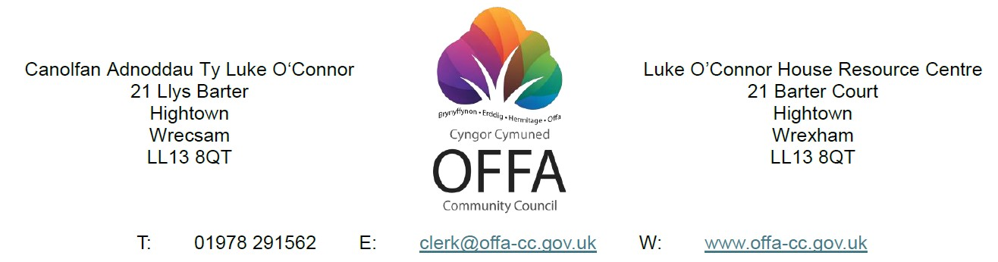

Dear Councillor,
You are summoned to attend the Planning and Environment Committee meeting at 7pm Thursday 30th April 2026 at Luke O’Connor House, 21 Barter Court, Wrexham, LL13 7QT and remotely by Zoom.

Please request the Zoom link by contacting the following email address.
deputyclerk@offa-cc.gov.uk

AGENDA

1: To receive and consider apologies for absence.

2. To receive declarations of Members’ interests.

3. To approve and sign the minutes of the Planning and Environment Committee meeting
held on Thursday 2nd. April 2026.

4. Matters arising - Response from Licensing Department

5. Public Session
A period not exceeding 12 minutes for Members of the Public to ask questions or
submit comments.

6. To consider the following Planning Applications: -

Application No 1: P/2026/0168
Description: LISTED BUILDING CONSENT FOR EXTERNAL SIGNAGE (ILLUMINATED AND NON-ILLUMINATED)
Site Address Wrexham County Museum, Regent Street, Wrexham, LL11 1RB

Application No 2: P/2026/0169
Description: ADVERTISEMENT CONSENT FOR 5 SIGNS
Site Address: Wrexham County Museum, Regent Street, Wrexham, LL11 1RB

Application No 3: P/2026/0174
Description: CHANGE OF USE OF 3 BEDROOM FLAT (CLASS C3) TO 3 BEDROOM HOUSE IN MULTIPLE OCCUPATION (HMO) (CLASS C4)
Site Address: First and Second Floor Flat, 36 Brook Street, Wrexham, LL13 7LL

Application No 4: P/2026/01183
Description: PROPOSED LOFT CONVERSION IN FAIRY ROAD CONSERVATION AREA
Site Address: 78, Ruabon Road, Wrexham, LL13 7PH

Application No 5: P/2026/0199
Description: DISCHARGE OF CONDITION 3 (Ventilation) of Planning Permission P/2025/0821
Site Address: General Stores, 70-70A Poyser Street, Wrexham, LL13 7RT

Application No 6: P/2026/0221
Description: WORKS TO TREES PROTECTED BY TREE PRESERVATION ORDER
WCBC 13
Site Address: 115, Norman Road, Wrexham, LL13 7BG

Application No 7: P/2026/0257
Description: DISCHARGE OF CONDITION 6 (Validation Report) of Planning Permission P/2024/1686)
Site Address: 35, Maesgwyn Road, Wrexham, LL11 2AP

7. Notification from WCBC re withdrawal of Local Development Plan.

8. To consider the following Member Items: -
NONE

9. To note the date of the next Planning and Environment Committee meeting:

Subject to the decision of the Annual General Meeting of the Council on May 14th., the next scheduled meeting of the Planning and Environment Committee will be held at 7pm, on Thursday 4th. June 2026, at Luke O’Connor House.

